

**SOFTWARE REQUIREMENTS SPECIFICATION**

**EVENT MANAGER**

C T Prasanth 12BCE0098

P Krishnan 12BCE0260

B.Joseph Sasikanth Reddy 12BCE0360

Guide: Prof Lydia Jane

**TABLE OF CONTENTS**

1. Introduction
2. Project Overview

2.1 Limitations of the current system

2.2 Project scope

1. Process Model
2. Project Schedule

4.1 Work-Load

4.2 PERT chart

4.3 Gantt chart

4.4 Project Timeline Chart

1. Functional & Non Functional Requirements
2. Stakeholders
3. Use case Model
4. Work breakdown structure
5. Project Resource Requirements

**1. INTRODUCTION**

Event Manager is web application software that smartly organizes events based on its intended targets. Manual process of organizing and arranging an event is quite a arduous task. Automating the process saves lot of time and manual effort. Even though there are many event managing softwares available, Event Manager is unique in its own kind as it would have a very User Friendly interface and it targets only the public for whom the event would be useful.

This is done through the forms submitted by the team leader with the approval of the head of department to the admin for organizing that particular event.

* 1. **Abstract**

Our project contains basically Authentication tags for:

* + 1. **Admin Login**

It manages all the event details, history, automatically allocate them based on their intended targets, Generate report and maintain system database.

* + 1. **Department Head Login**

It plays a major role in creating teams and approving events and also maintains the history of events.

* + 1. **Team Lead Login**

It helps to submit the event details through a form.

* + 1. **Team Members Login**

It helps to maintain their profile and receive messages from the team lead on what to do.

**2. PROJECT OVERVIEW**

**2.1 Limitations of current system**

**1.** Efficiency of organizing an event manually is low.

**2.** Existing systems takes lot of memory as it displays contents to public which are not of their interest.

**3.** Current systems are unorganized.

**4.** Lack of different views to the organized data.

**5.** Existing systems are less secure.

**2.2 Project scope**

* Some events don’t get the recognition they deserve, the main method of this communication is through posters or mouth to mouth.
* The main scope of our project is to automate this whole process of organizing an event.
* Manual efforts are being reduced drastically since everything is automated.

**3.PROCESS MODEL**

The process model basically describes the sequence of phases for the entire lifetime of our project. This covers everything from the initial planning till the final disassembling after its use.

We have planned to use the v and v model. Since we will be creating the individual web pages initially and link them at the later stages. As we are creating the individual web pages we will also plan for its testing in the later stages of the project.

**The steps for V & V Model can be generalized as follows:**

* Our project contains different web pages for different members hence every page has to be tested in separate units and linking will be done later with the integration testing.
* As we are creating individual web pages for different members. We plan ahead of its testing

**V & V MODEL**

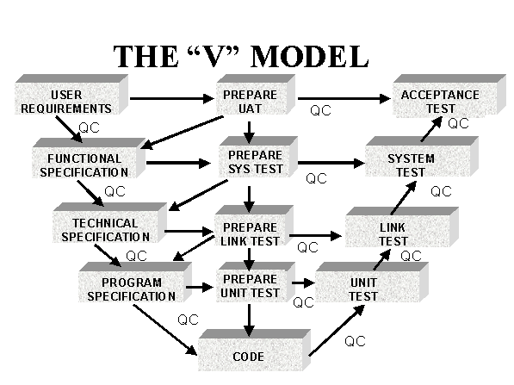

**Figure 1**

**4. PROJECT SCHEDULE**

**4.1 Work Split-Up:**

|  |  |  |  |
| --- | --- | --- | --- |
| **S.NO** | **WORKLOAD** | **NAME** | **REG NO** |
| 1 | Planning which includes scheduling and process model identification. | B.JOSEPH | 12BCE0360 |
| 2 | SOFTWARE REQUIREMENT SPECIFICATION | B.JOSEPH | 12BCE0360 |
| 3 | Software Design | P KRISHNAN  C T PRASANTH | 12BCE0260  12BCE0098 |
| 4 | Coding | P KRISHNAN  C T PRASANTH | 12BCE0260  12BCE0098 |
| 5 | Testing | P KRISHNAN  C T PRASANTH | 12BCE0260  12BCE0098 |
| 6 | Retrosepective Analysis | B.JOSEPH | 12BCE0360 |

**Figure 2**

**4.2 PERT CHART**



**Figure 3**

**4.3 GANTT CHART**

**Figure 4**

**4.4 PROJECT TIMELINE CHART**



**Figure 5**

**5.FUNCTIONAL REQUIREMENTS:**

|  |  |  |
| --- | --- | --- |
| **Sno** | **Function name** | **Function Description** |
| 1 | Registration | Provides a signup option for the department head, team lead and team member. |
| 2 | Login | Provides a basic authentication to access the user’s functionalities. |
| 3 | Search | Provides a space to find contents according to the given keyword. |
| 4 | Message | Provides a option to communicate via text messages. |
| 5 | Profile | Provides detailed information about the user. |
| 6 | Teams | Provides control for the department head to add, modify or delete team and its members. |
| 7 | History | Provides the report of various events conducted before and the forms which are approved or rejected. |
| 8 | Forms | Provides a platform for the team lead to register their events to their department head. |

**Table 1**

**5.1. NON FUNCTIONAL REQUIREMENTS**

|  |  |  |
| --- | --- | --- |
| **Sno** | **Name** | **Description** |
| 1 | Security | Only authenticated members can use their functionalities. |
| 2 | Performance | The software is built in such a way that it uses less amount of memory yet it performs smoothly. |
| 3 | Accuracy and Precision | The entered data are updated accurately with great precision |
| 4 | Portability | Since it is a web-software it can be easily accessed. |
| 5 | Modifiability | Software can be easily modified according to the user requirements later on. |

**Table 2**

**6. STAKE HOLDERS**

1. **Department head:**

He is the one who approves any event that has benn submitted by the team lead and also can edit the teams under him.

1. **Team Lead:**

He is the one who organizes event by submitting the form and maintain the team members by assigning corresponding work through messages.

1. **Team Members:**

Team members work under the team lead and help to organize event successfully.

1. **Admin:**

Admin has the ability to authenticate the department head and can display events and also has the access to every member’s profile.

**7.USE CASE MODEL**

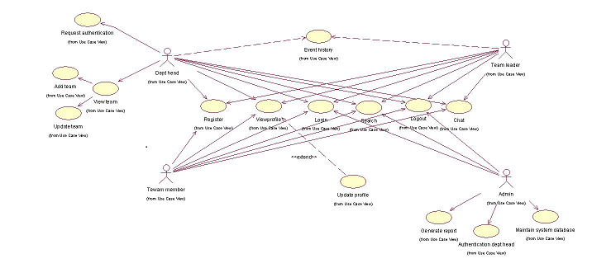

**Figure 6**

**8.WORK BREAK DOWN STRUCTURE**

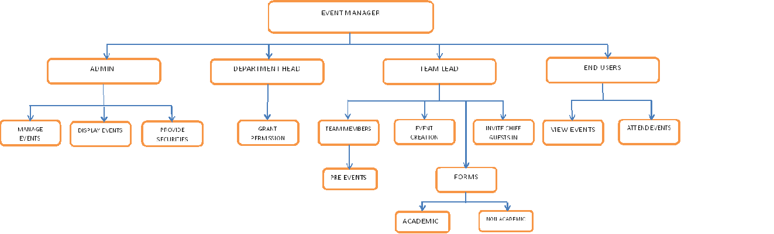

**Figure 7**

**9.PROJECT RESOURCE REQUIREMENTS**

**9.1 Hardware Specifications**

* Processor : Pentium IV or above
* Hard Disk : 120 GB or above
* RAM : 1 GB or above

**9.2 Software Specifications**

* Operating System : Windows XP
* User Interface : HTML, CSS
* Client-side Scripting : JavaScript
* Programming Language : Java, J2EE
* Web Technologies : JDBC, JSP
* Frameworks : Struts 1.2
* IDE/Workbench : Eclipse 3.0
* Database : MySQL
* Server Deployment : Apache Tomcat 6